**DETAILS**

The following steps explain how to input *VBA* code in *Excel*®.

* Start *Excel*
* Go to *Tools* menu/*Macro*/*Visual Basic Editor*
* On the *VBAProject* bar on the left, double-click on *ThisWorkbook*
* In the code window,write or paste the*VBA*code
* Select the name of a function and then go to *Run* menu/*Run Sub/UserForm*, or press F5

## SUMMARY

How to start *Simcenter* MAGNET as a COM Automation Server from Excel using external scripting.

## DETAILS

This example will show how to start *MagNet* as an Automation Server from Excel ® (the Automation Client), and have it execute the script file instructions created in the [Script File example](https://support.mentor.com/knowledge-base/MG601586).

# **Instructions**

1. Open the [SquareComponent.xlsm](https://support.sw.siemens.com/kbassets/external/MG601588/files/SquareComponent.xlsm) file and assign a blank macro to the Square component button.
   1. Right-click on the button and select Assign Macro… as shown below on left.
   2. In the Assign Macro dialog displayed, click the New button (below right).

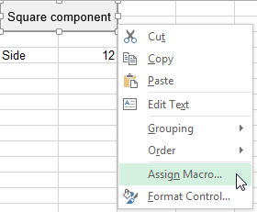   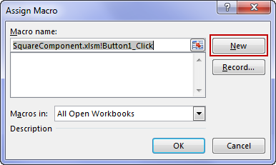

* 1. A Visual Basic for Applications editor window is then opened, ready to receive the code that will be associated to the button.

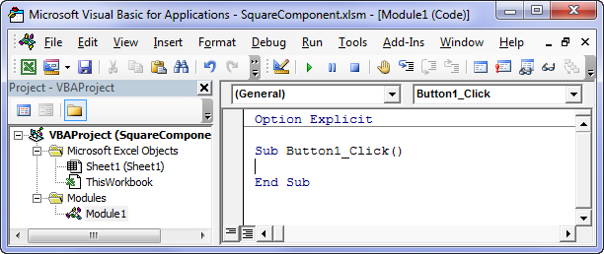

1. Take the code from the [*SquareComponent.vbs*](https://support.sw.siemens.com/kbassets/external/MG601588/files/SquareComponent.vbs) script file and insert it in the Button1_Click module.

The modified module should be as shown below. Note that it is not yet functional because *MagNet* scripting APIs such as *newDocument* are not defined in Excel.

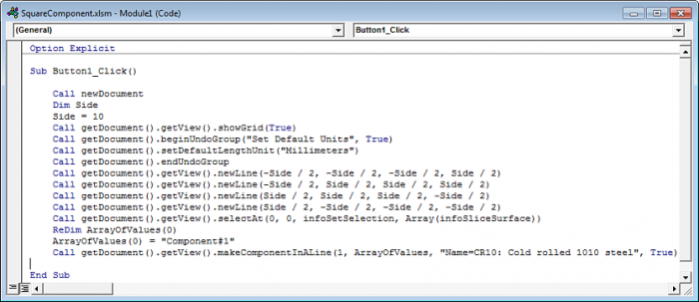

1. Create the *MagNet* and Constants objects at the beginning of the Excel module, which will allow the link between *MagNet* and Excel to be properly defined.

The required statements are the following:

Dim oMN As Object, oCst As Object  
Set oMN = CreateObject("Magnet.application")  
Set oCst = oMN.getConstants 'Get the Constants object

1. Add a statement that will make the *MagNet* window visible.

The required statement is the following:

oMN.Visible = True 'Make the MagNet window visible

1. Prefix the *MagNet* API calls with the name of the *MagNet* application object, the constants with the Constants object and set the Side variable to read its input value from cell B4.

The resulting code is shown below with the requested changes highlighted.

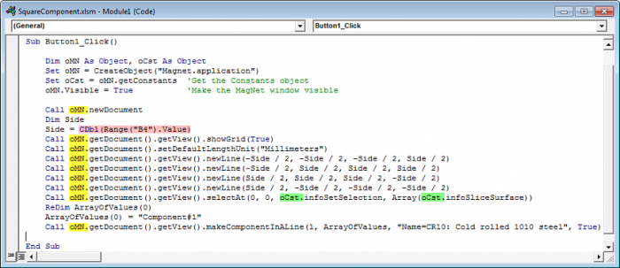

1. Click the Square component button and confirm that a new *MagNet* session is automatically started and a square component with 12-unit sides is constructed.

The expected *MagNet* window is shown below.

